**ANNA UNIVERSITY REGIONAL CAMPUS, COIMBATORE - 641 041**

**DEPARTMENT OF ELECTRONICS AND COMMUNICATION ENGINEERING**

**ACADEMIC YEAR 2023-2024 (SEMESTER 5)**

**IBM NAAN MUDHALVAN CLOUD COMPUTING PROJECT 3: PERSONAL BLOG ON IBM CLOUD STATIC WEB APP**

**PHASE 3: DEVELOPMENT PART 1**

**(Preprocessing the dataset)**

**DONE BY,**

RUTHRAKUMAR S

710021106304

**PROJECT NAME:**

**PERSONAL BLOG OF STATIC WEB PAGE**

**PROJECT SUBMISSION: DEVELOPMENT PART 1**

**HTML CODE:**

**<!DOCTYPE html>**

**<html>**

**<head>**

**<title>Travel Website</title>**

**<link rel="preconnect" href="https://fonts.gstatic.com">**

**<link href="https://fonts.googleapis.com/css2?family=Poppins:wght@300&display=swap" rel="stylesheet">**

**<link rel="stylesheet" type="text/css" href="./style.css">**

**</head>**

**<body>**

**<div class="navbar">**

**<div class="logo">**

**<h1>Travel</h1>**

**</div>**

**<div class="menu">**

**<ul>**

**<li><a href="#">HOME</a></li>**

**<li><a href="./travel/html.html">TRAVEL STORIES</a></li>**

**<li><a href="./photogallery.html">TRAVEL TIPS</a></li>**

**<li><a href="./sidebar/index.html">PHOTO GALLERY</a></li>**

**<li><a href="./map.html">MAP</a></li>**

**<li><a href="./contact.html">CONTACT</a></li>**

**<li><a href="#">ABOUT ME</a></li>**

**</ul>**

**</div>**

**<div class="signup">**

**<a href="#">Sign Up</a>**

**</div>**

**</div>**

**<div class="body">**

**<div class="heading">**

**<h1>Travel With Us</h1>**

**<br>**

**<p>ipsum dolor sit amet, consectetur adipisicing elit, sed do eiusmod**

**tempor incididunt ut labore et dolore magna aliqua. </p>**

**<br>**

**<br>**

**<a href="#">Learn More</a>**

**</div>**

**<div class="tours">**

**<div class="places">**

**<h2>Australia</h2>**

**<img src="img1.jpg" style="width: 300px; height: 250px; border-radius: 12px;">**

**<br>**

**<br>**

**<a href="#">Book Now 15% OFF</a>**

**</div>**

**<div class="places">**

**<h2>New York</h2>**

**<img src="img2.jpg" style="width: 300px; height: 250px; border-radius: 12px;">**

**<br>**

**<br>**

**<a href="#">Book Now 20% OFF</a>**

**</div>**

**<div class="places">**

**<h2>Thailand</h2>**

**<img src="img3.jpg" style="width: 300px; height: 250px; border-radius: 12px;">**

**<br>**

**<br>**

**<a href="#">Book Now 25% OFF</a>**

**</div>**

**</div>**

**</div>**

**<div class="footer">**

**<a href="#">Copyright</a>**

**<a href="#">Terms and Conditions</a>**

**<a href="#">Privacy Policy</a>**

**<a href="#">Cookies</a>**

**<a href="#">Complaints</a>**

**</div>**

**</body>**

**</html>**

**STYLE.CSS:**

*{

    padding: 0px;

    margin: 0px;

    box-sizing: border-box;

    list-style: none;

    font-family: 'Poppins', sans-serif;

}

.navbar{

    width: 100%;

    height: 80px;

    background-color: #fee;

    display: flex;

    justify-content: space-around;

    align-items: center;

    color: #000;

}

.menu ul{

    display: flex;

    align-items: center;

}

.menu ul li a{

    text-decoration: none;

    color: #000;

    padding: 5px 12px;

    letter-spacing: 2px;

    font-size: 18px;

}

.menu ul li a:hover{

    border-bottom: 4px solid #000;

    transition: 0.4s;

}

.signup a{

    text-decoration: none;

    color: #000;

    font-size: 18px;

    font-weight: bold;

    border-radius: 12px;

    padding: 12px 30px;

    border: 2px solid #ff0000;

}

.signup a:hover{

    background-color: red;

    transition: 0.6s;

}

.body{

    width: 100%;

    height: 90vh;

    display: flex;

    justify-content: space-around;

    align-items: center;

    background-image: linear-gradient(rgba(0,0,0,0.50),rgba(0,0,0,0.50)),url(img1.jpg);

    background-position: center;

    background-size: cover;

}

.heading{

    width: 30%;

    text-align: center;

    color: #fff;

}

.heading h1{

    font-size: 40px;

}

.heading a{

    text-decoration: none;

    color: #000;

    font-size: 25px;

    font-weight: bold;

    border-radius: 45px;

    padding: 14px 50px;

    background-color: #fff;

}

.heading a:hover{

    letter-spacing: 3px;

    transition: 0.6s;

}

.tours{

    width: 70%;

    display: flex;

    justify-content: space-around;

}

.places{

    display: inline;

    text-align: center;

    border-radius: 12px;

}

.places h2{

    color: red;

    font-size: 35px;

    letter-spacing: 3px;

    border-radius: 1px;

    padding: 30px 30px;

    background-color: #000;

}

.places a{

    text-decoration: none;

    color: red;

    font-weight: bold;

    font-size: 18px;

    border-radius: 12px;

    padding: 12px 30px;

    background-color: #fff;

}

.places a:hover{

    background-color: #000;

    letter-spacing: 3px;

    transition: 0.6s;

}

.footer{

    width: 100%;

    height: 50px;

    display: flex;

    justify-content: space-around;

    align-items: center;

}

.footer a{

    text-decoration: none;

    color: green;

    font-size: 18px;

    font-weight: bold;

}

.footer a:hover{

    text-decoration: underline;

    transition: 0.4s;

}

**PHOTOGALLERY.CSS:**

@import url("https://fonts.googleapis.com/css2?family=EB+Garamond:ital,wght@0,400;0,500;0,600;1,400;1,500;1,600&display=swap");

body {

  max-width: 800px;

  margin: 0 auto;

  background: #e7dfcf;

}

section {

  margin: 80px 0;

    display: grid;

  grid-template-areas: "title title img3 img3"

                        "img2 img1 img3 img3";

  grid-gap: 8px;

}

h2 {

  grid-area: title;

  color: #111;

  font-size: 120px;

  font-family: "EB Garamond", serif;

  font-weight: normal;

  margin: 0 0 20px 0;

  position: relative;

  z-index: 1;

  line-height: 1;

  mix-blend-mode: hard-light;

  max-width: 240px;

}

h2 span {

  font-weight: bold;

}

h2::after {

  display: none;

  content: "";

  height: 8px;

  border-radius: 30px;

  width: 70%;

/*   display: block; */

  background: currentColor;

  transition: 0.5s ease;

}

h2:hover::after {

  transform: translateX(50%);

}

section img:nth-child(4) {

  grid-area: img3;

  aspect-ratio: 3 / 4;

}

section img:nth-child(1) {

  grid-area: img1;

}

section img:nth-child(2) {

  grid-area: img2;

}

section img {

  aspect-ratio: 4 / 3;

}

img {

  max-width: 100%;

  width: 100%;

  height: 100%;

  border-radius: 5px;

  object-fit: cover;

  transition: 0.3s ease;

    box-shadow: 0 1px 3px 0 rgb(0 0 0 / 0.1), 0 1px 2px -1px rgb(0 0 0 / 0.1);

}

**IMAGES:**

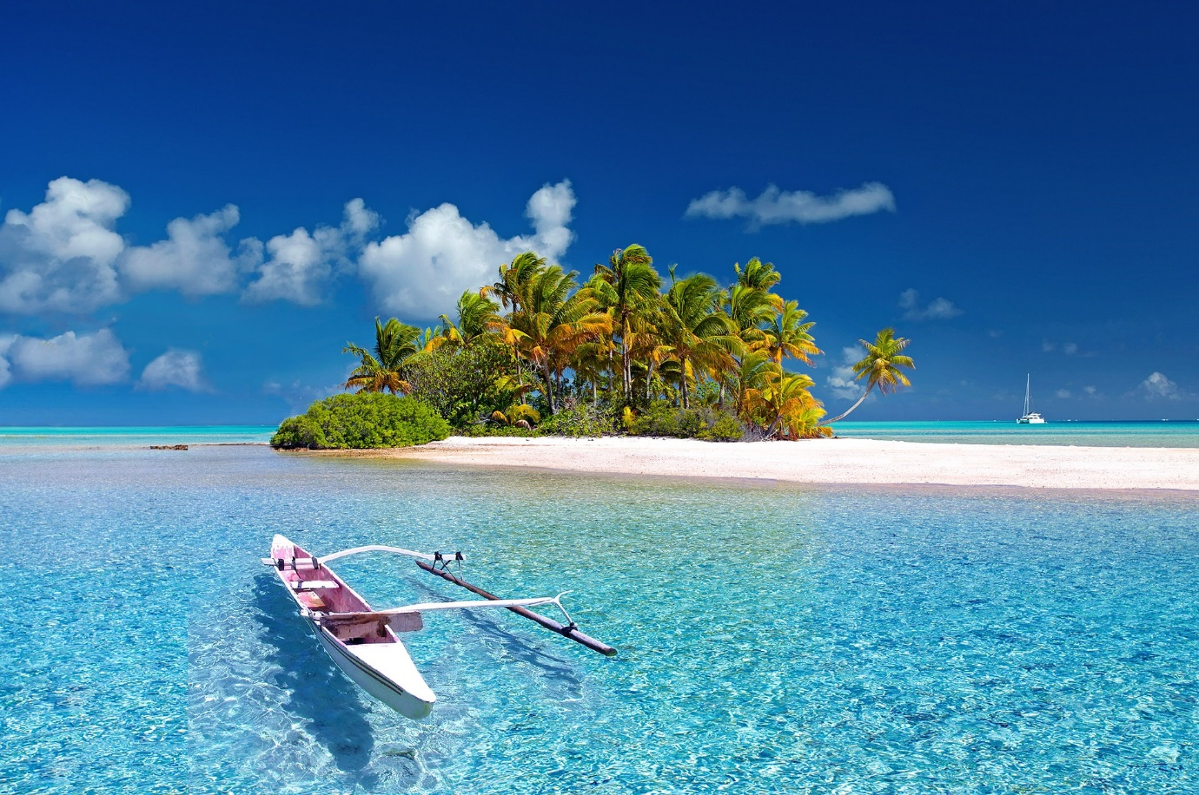

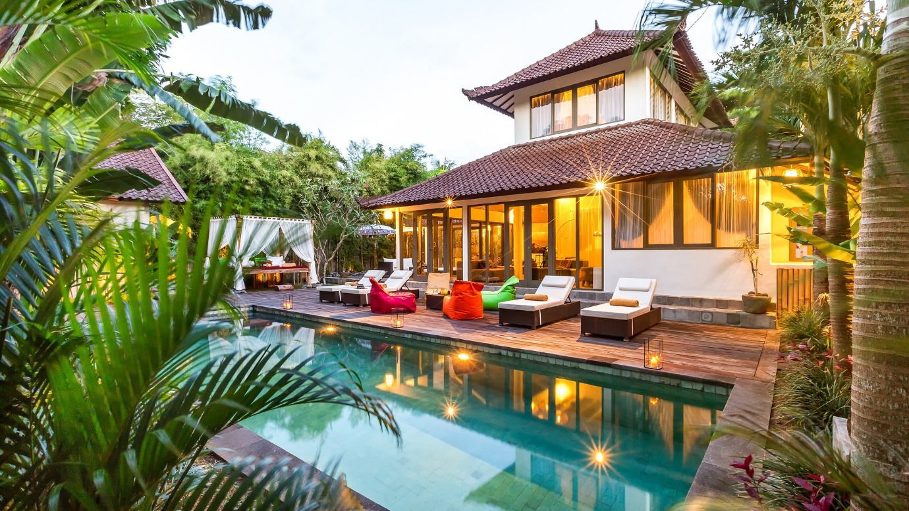

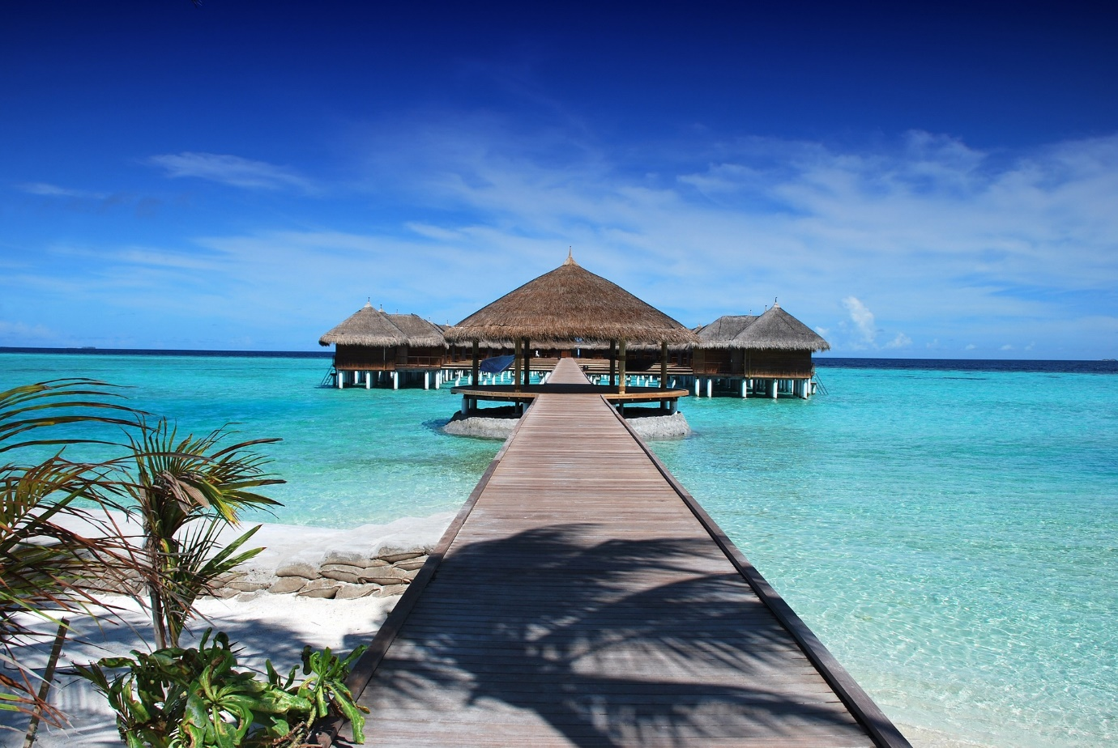

**MAP:**

